

***The Novair F2105***   
  
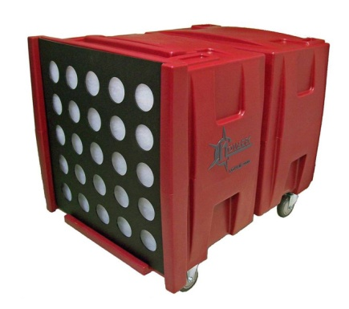**"The complete package!"** Our most powerful, durable & light weight Negative Air Machine available! ***Virtually Indestructible!***

**FEATURES AND BENEFITS:**• Powerful 2HP motor generates exceptional, consistent flow rate and utilizes all filter media area   
• 2 speed motor-provides consistent air flow of 2000cfm (high speed) and 1000cfm (low speed)  
• 8 point motor/cage mounting prevents motor and cage shifting under the harshest conditions   
• Seamless construction guarantees leak proof operation   
• One of the lightest 2000cfm units on the market is easily transported by 2 operators   
• Positive lock filter prevents filter movement for uninterrupted filtration   
• Uses standard 24" x 24" H.E.P.A. filters, rated 99.97% efficiency against 0.3 micron particles   
• General Purpose Filters & Audible Alarms are also available  
• Custom controls & features available upon request

|  |  |  |  |  |  |  |
| --- | --- | --- | --- | --- | --- | --- |
| F2105 | 118lbs | 37" x 26" x 31" | 2HP-Two Speed,  Thermally Protected | High-2000cfm Low-1200cfm | 115Volt 15 Amp, 60Hz | 1/2" Pad / Ring Filter |

|  |  |  |  |  |
| --- | --- | --- | --- | --- |
| ring | Pad |  | door | hepa |
| **Ring Filters Part No: 55014** | **Pad Filter Part No: 55007** |  | **12" Vacuum Intake Door Part No: A31091** | **General Purpose Filter Kit Part No: A30176**  **Replacement General Filter Only:** **A40023** |